**Project:**

**‘PizzaHunts’**

**Sales Analysis Report**

Content

* Problem Statement
* Business Problems / Analytical Goals
* Tools
* Solution Approach
  + Step-1: Understanding Source data and analytical goals
  + Step-2: Data Cleaning
  + Step-3: Data processing
  + Step-4: Data Analysis
  + Step-5: Visualization OR Dashboarding
  + Step-6: Analysis Validation
* Visualization Charts
* Final Dashboard Report (Screenshots)
* Derived Insights
* Problem Statement

There is a popular food outlet in the town specifically a Pizza shop, known as ‘*Pizza Hunts’*. They have a large variety of Pizzas to serve their customers. They are the 1st Pizza shop in the town and have been dominating their town market for the last 12 years. However, in the last 2 to 3 years their market share has decreased due to increasing Competitors.

They are planning to regain their market share by making smart moves and implementing new strategies. Therefore, they reach out to you as a data analyst, so that they get a detailed sales analysis report based on their last year's (2015) data.

Your job is to develop a sales report using their provided data which able to cater to the business problems they want to be resolve. Consider their business problems as analytical goals for the report.

Due to the sales analysis report your client will get a concise understating of their sales performance and buying nature of the customer behavior.

* Business Problems / Analytical Goals

1. KPIs to evaluate the business performance at a higher level Total Revenue
   1. Total orders
   2. Average order value
   3. Total Pizza units sold
   4. Average Pizzas per order
2. Show the monthly trend for Revenue.
3. Which are the busiest days in terms of sales?
4. What are the busiest hours in a day for sales?
5. What is the % distribution of sale ($) by Pizza size?
6. What is the % distribution of sales ($) by Pizza Categories?
7. Which are the top 5 Pizzas by the sold Quantity?
8. Which are the top 5 Pizzas by the sold Quantity?
9. Sold Pizza’s Quantity distribution by different Pizza categories?

The whole analysis report should be filterable by different months individually.

* Tools

1. Microsoft Excel
2. MS SQL Server and MS SQL Management Studios.

* Solution Approach

**Step 1: Understanding Source data and analytical goals**

The first and most important thing is to understand the given raw data based on the business problems we going to solve. The company’s business problems should be considered as analytical goals that will be implemented while creating the dashboard report.

**Step 2: Data Cleaning**

The next step we going to approach is cleaning the provided raw data, as the data may probably contain null values, empty values, or values that may be inconsistent in some columns.

Example.

the Quantity column contains values: 1, 2, 3, 4, … and “one”, “two” etc.

Once we clean our raw data and transform it into a consistent set of data, we can consider it as our source data further.

**Step 3: Data Processing**

In the step of data processing, we tend to perform some sort of data calculations and derive some new columns that will be required for making analysis.

To conclude which set of columns should be calculated and added to the source data, we need to make observations about the source data and the analytical goals. Whether there is any information gap that should be filled.

Once we add up all the crucial derived columns to the source data we have done with data processing and we are good to go for the next step.

**Step 4: Data Analysis**

This is the most exciting part of our project where we will bring our data to life by creating visualization elements bar graphs, pie charts slicer elements, and timeline elements, by implementing pivot charts.

The selection of appropriate visualization charts is a crucial task, it is dependent on the analytical problem statements/ goals trying to cater

In this step, we have created all the pivot tables and respective pivot charts to analyze each business problem individually.

**Step 5: Data Visualizations / Dashboarding**

After validating our analytical values, we created the dashboard by putting all the created individual pivot charts together.

**Step 6: Data / Analysis Validation**   
In this step, we have to cross-check the output numeric values of visualization charts in the project. To validate whether the output values are accurate and errorless we have executed a list of SQL queries for every visualization chart.  
We have created an analysis validation report for the project which consists of all SQL queries along with their output screenshots.

Kindly refer to the report.

* Visualization Charts

1. Sales ($) trend throughout the year (2015)

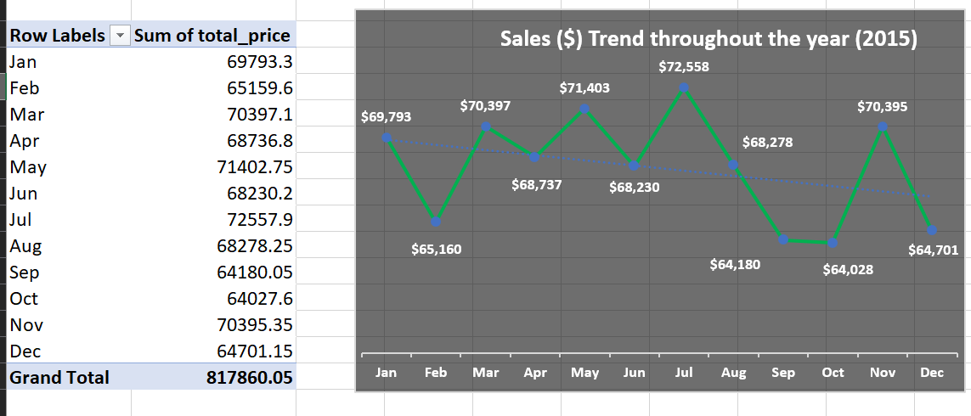

1. 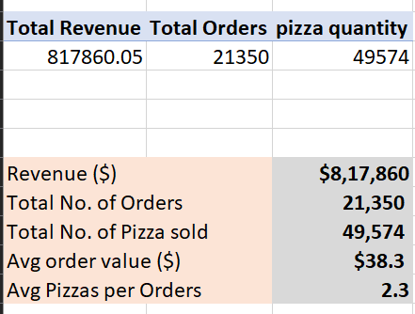KPIs



3. Weekly Trend- Orders

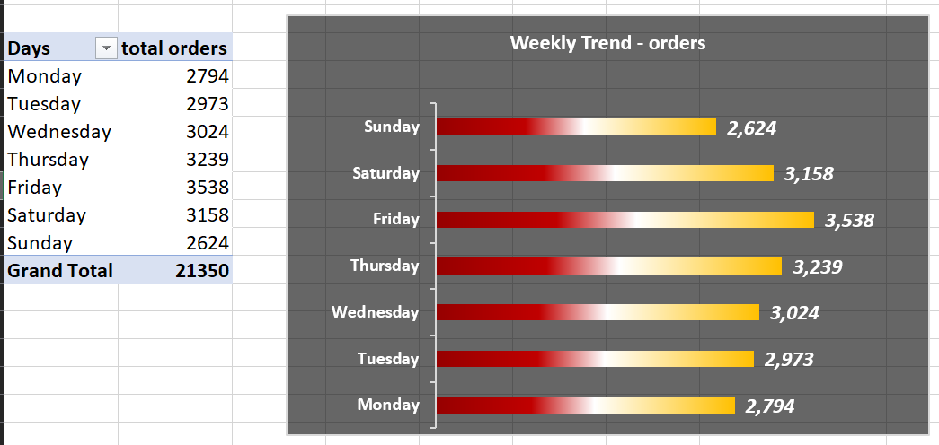

4. Hourly Trend of Orders

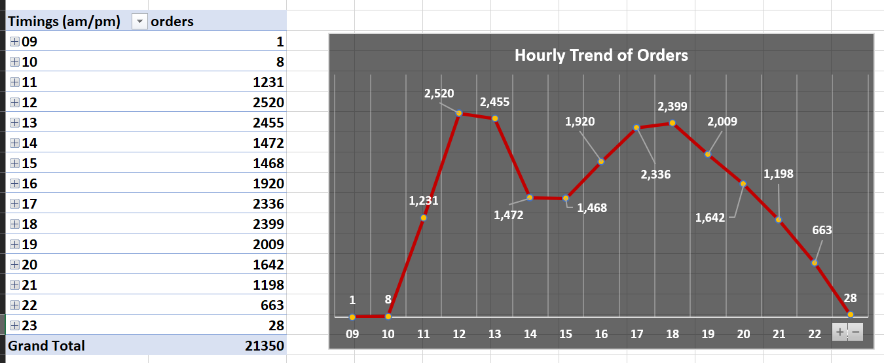

5. % Sales ($) by Pizza Category

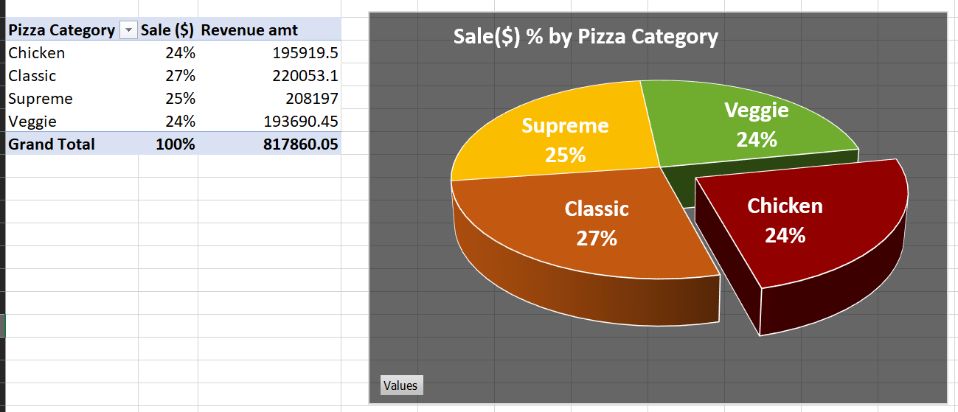

1. % Sales ($) by Pizza Size

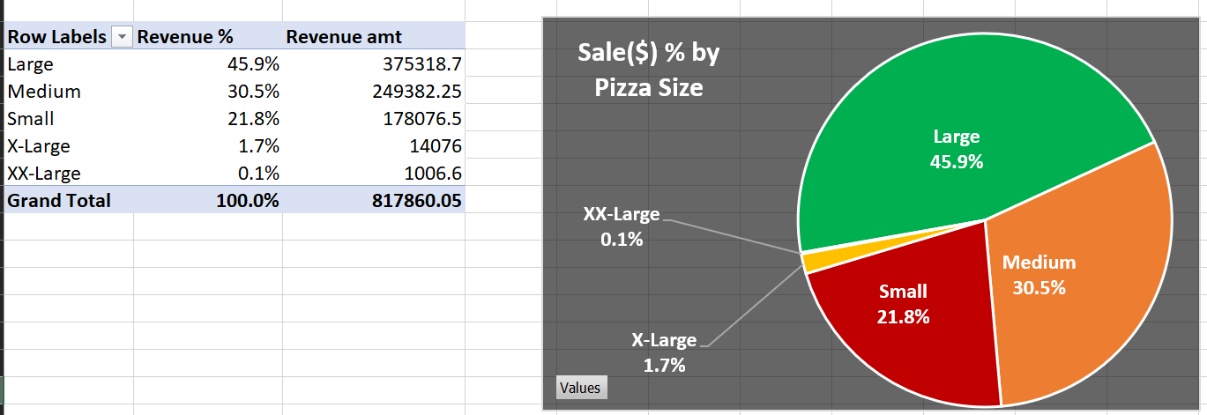

1. Quantity sold by Pizza Category

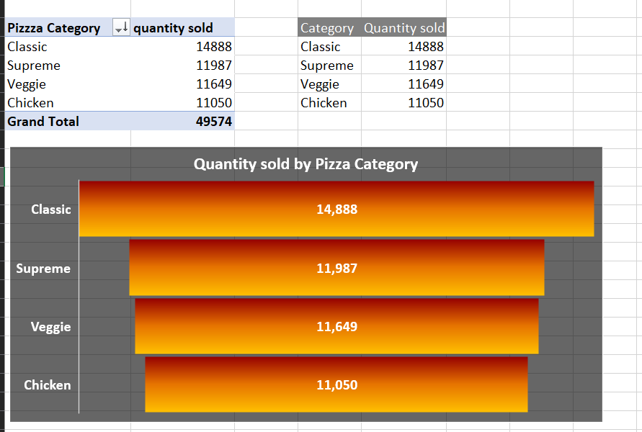

1. Top 5 Pizzas by Sold Quantity

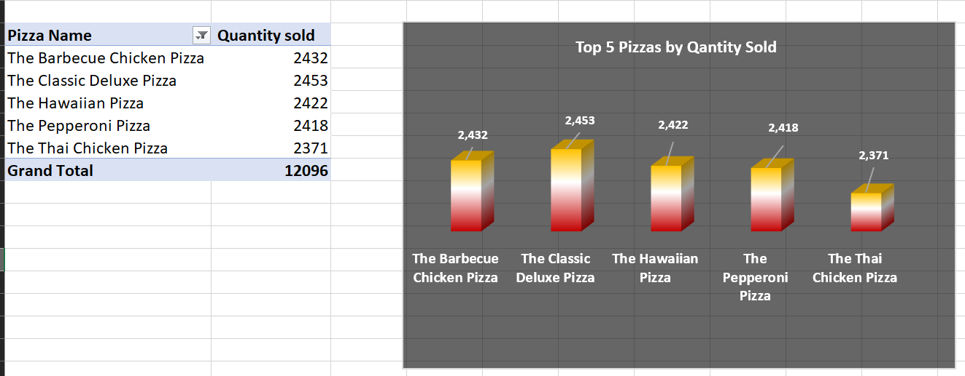

1. Bottom 5 Pizzas by sold Quantity

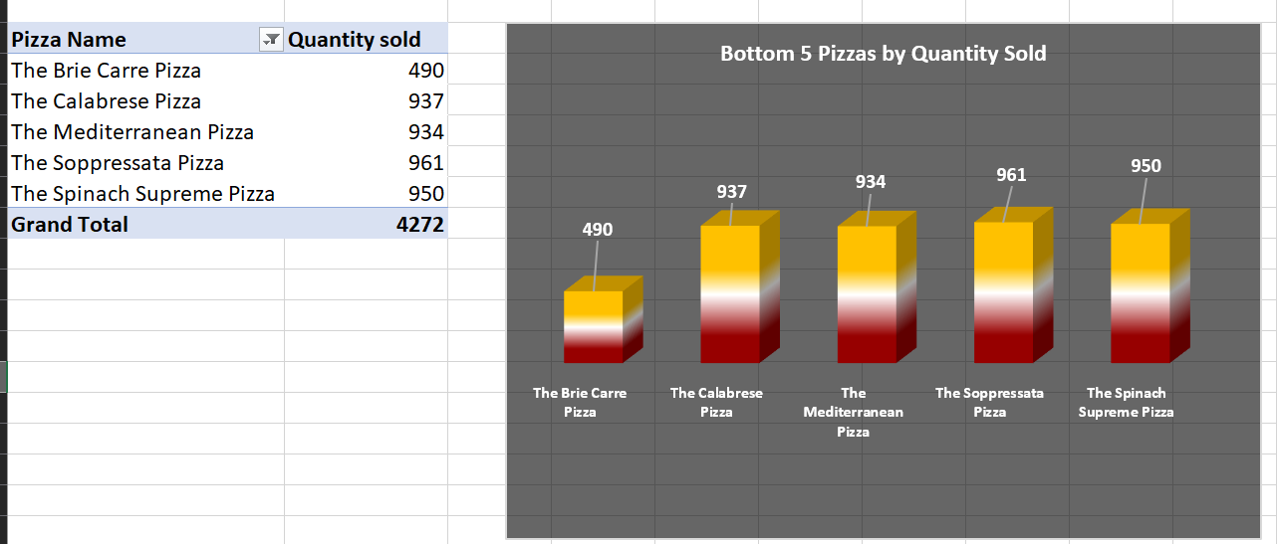

* Final Dashboard Report

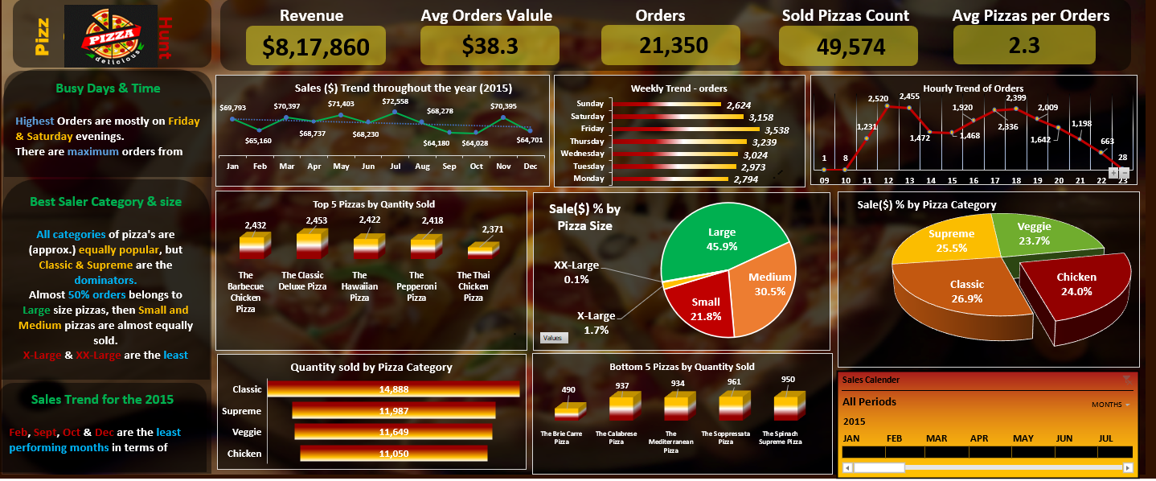

After applying filters-

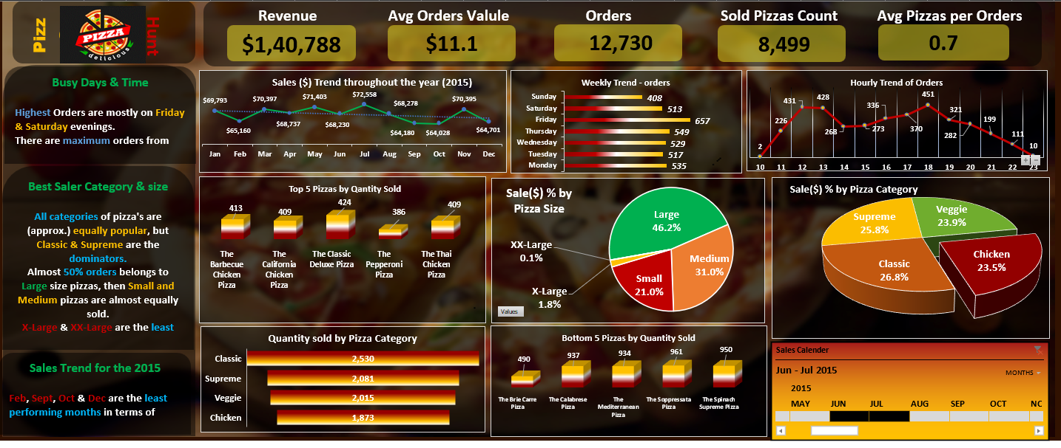

* Derived Insights

1. Primary KPIs-
2. Total Revenue = $0.8178 Million
3. Total No. of Orders = 21,350
4. Average Order Value = $38.3
5. Total No. Pizza units sold = 49.5 k
6. Average Pizzas per Orders= 2.3 Pizzas
7. Business was not performed well in Feb, Sept, Oct & Dec

revenue was around or below $65k.

1. Customer crowd is highest on Friday & and Saturday, that is on pre-weekend days.

**#Recommendation –**

**There is a potential to generate sales on Weekdays, that is from Monday to Thursday, by implementing new strategies like special discounts, exciting combo packs, free home delivery, etc.**

1. Highest orders are placed between 12 pm to 1 pm time, and from 4 pm to 8 pm times.
2. All categories of Pizzas are almost equally popular, but the Classic and supreme categories are quite more popular.
3. People prefer to buy Large size Pizzas (50% approx.), than Medium and small size pizzas. X-Large & and XX-Large Pizzas are the least ordered ones.

**# Recommendation:**

**If we increase the price of large-size pizzas (around 20% to 30%), overall Revenue will automatically grow (by 10% to 15%).**

**So, manipulating the price range of Large-size Pizzas would be efficient to increase profits.**

1. Top 5 Pizzas by the quantity sold are-
2. The Classic Deluxe Pizza
3. The Barbecue Chicken Pizza
4. The Hawaiian Pizza
5. The Pepperoni Pizza
6. The Thai Chicken Pizza

**#Recommendation:**

**There is a potential to increase Revenue by Price Manipulation over these top 5 Pizzas.**

1. Bottom 5 Pizzas by the quantity sold-
2. The Brie Carre Pizza
3. The Calabrese Pizza
4. The Mediterranean Pizza
5. The Soppressata Pizza
6. The Spinach Supreme Pizza

**#Recommendation:**

**Try to replace these items by introducing new varieties of pizzas.**

----------------------------------------------------------------------------